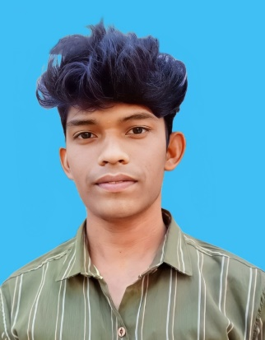 **VIJAYAKUMAR R**

**Email :** cecsvijayakumar25@gmail.com

**Contact :** +919003694806

**Address :** 8/1,

Thambi kalai iyyan kovil,

Thaneer panthalpalayam(PO),

Perudurai(TK),

Erode-638116.

**Linkedin :** <https://www.linkedin.com/in/vijayakumar-r-598584269>

**GitHub :** https://github.com/vijayakumarCSE25

**CAREER OBJECTIVE:**

Continuously enhance my coding skills and expand my knowledge by exploring cutting-edge technologies, frameworks, and languages. Apply this expertise effectively to develop efficient, scalable, innovative software solutions.

**ACADEMIC PROFILE:**

* **BE Computer Science (2025)** – K.S.R College of Engineering

**CGPA**-**7.1** (upto 5TH sem)

* **HSC (2021) –** Sri Venkateshwara Vidhayalayaa Higher Sec. School

**Score - 76%**

* **SSLC (2019 ) –** TNK High School

**Score - 62%**

**AREA OF INTERESTS:**

* Web Development

**MINI PROJECTS:**

* Created a personal portfolio using HTML, CSS and JavaScript.
* Created a game Website using HTML,CSS and JavaScript – Breakout Ball Game.
* Created a event gallery using HTML,CSS and JavaScript.

**TECHNICAL SKILL SETS:**

* Front End : HTML, CSS, JavaScript
* Back End : Java

**LANGUAGES KNOWN:**

* English
* Tamil

**CO-CURRICULAR ACTIVITIES:**

* Done a workshop presentation at Knowledge Institute of Technology March 2023

**Topic:** “Frontend Mania”

* Done a paper presentation at Coimbatore Institute of Technology on March 2024

**Topic:** “Artificial Intelligence”

* Completed the Salesforce Developer Virtual Internship on February 2024.

**INDUSTRY DRIVEN COURSES:**

* Completed Cloud computing course in NPTEL on November 2023.
* Completed Getting Started With Azure Devops Boards in Coursera on September 2023.
* Completed Introdection to Industry 4.0 and Industrial Internet of Things on April 2024 .

**EXTRA-CURRICULAR ACTIVITIES:**

* Secured Second prize in the in zonal Kabaddi tournament conducted in TNK Vidyamandhir High School 2018.
* Secured third place in Photography in Media Club Activity by K.S.R. college of Engineering in April 2023.
* .

**PERSONAL PROFILE:**

Father’s Name : Ramasamy P

Mother’s Name : Rathna R

Date of Birth & Age : 26.03.2004 & 20 years

Nationality : Indian

Hobbies : Photograpy and Adobe Photoshop Editing

Traits : Adaptive, Collaboration

**PLACE:** Tiruchengode **(VIJAYAKUMAR R )**